**Do Now Name: ____________________________**

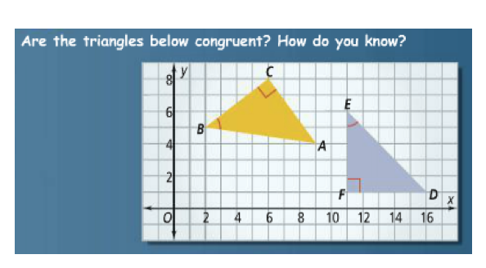

**Do Now Name: ____________________________**

